Introduction to Computer Networks Labsheet2

Analyzing the Web pages accessed using Wireshark
Name: Girish S
Roll: AM.EN.U4AIE22044
Part1: Mapping the given URL to IP address using nslookup
To run nslookup in Linux/Unix, you just type the nslookup command on the command line. To run it in Windows, open the Command Prompt and run nslookup on the command line.
We as humans usually use the website address known as Uniform Resource Locator (URL) to identify the destination host. But IP address is used by the devices to identify the server in the network. Domain Name System (DNS) service by the DNS server helps the client to translate an unknown URL to an IP address and also cache it in the device itself for subsequent access. The local cache maintains DNS record having a map between URL and IP address.

In it is most basic operation, nslookup tool allows the host running the tool to query any specified DNS server for a DNS record. To accomplish this task, nslookup sends a DNS query to the specified DNS server, receives a DNS reply from that same DNS server, and displays the result.
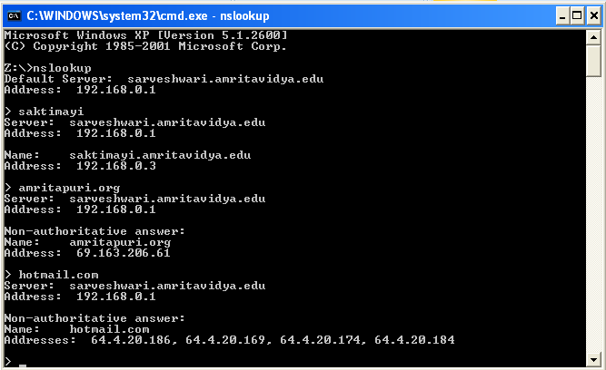
The IP address of abc.com is 18.67.161.122
The IP address of google.com is 142.250.182.142
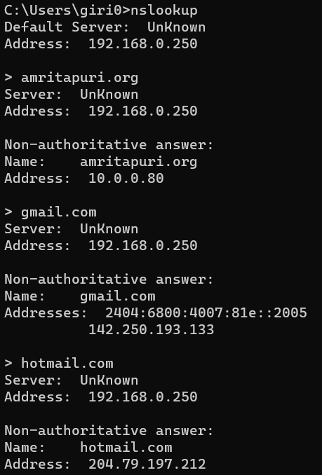
Find the IP address of all websites that you are using for Part2.
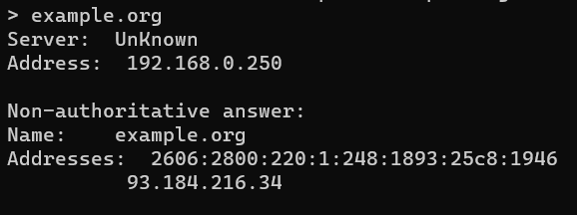

Part2: Understanding the TCP/IP protocol stack using Wireshark
- Open Packet sniffer [Wireshark] Application and Capture the Wi-Fi/ Ethernet Interface
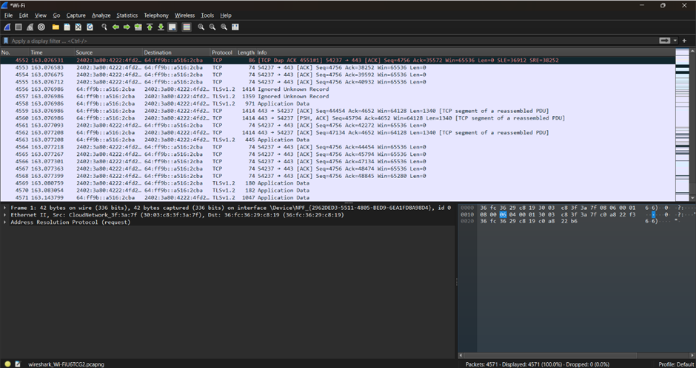
- Do this activity and capture frames.
a. Request for a web page by typing the least used URL in the webserver
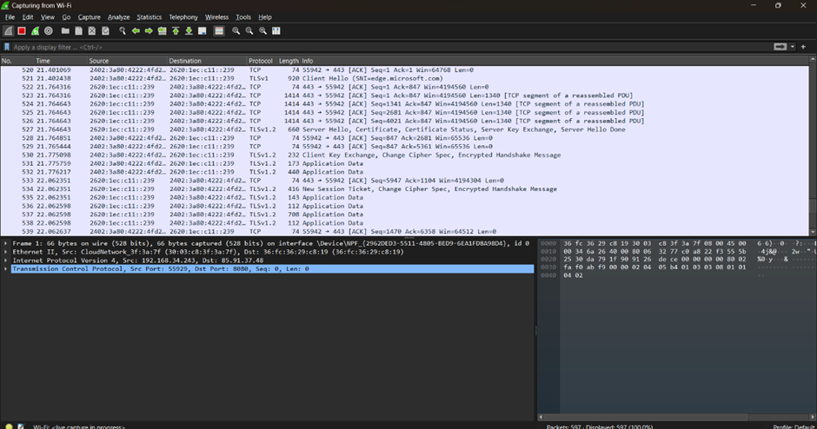
- Briefly explain the Encapsulation process in at least one http request frame of the protocol analyzed. Also complete the table below by PDU contents and details requested in each layer. Also try to provide proof in the form of a relevant screenshot.
Ans - When a request is sent from the application layer, the data (message) can be divided and split into capsules called TCP segments. These segments are further packeted into IP packets which have source and destination address. This is further covered in an ethernet frame which has the source and destination MAC addresses. These packets are now transmitted to other networks by the router. Finally, the data converts from electrical signals to optical signals in the physical layer.

Layer | Protocol | Important Contents (You can get details on clicking on a packet) | Purpose of the content specified in the Layer
Application | HTTP | GET request | To provide network services to end services
Transport | TCP | Provides source and destination port | Segmenting data into packets and managing the flow of transport
Internet | IPV4 | Provides source and destination IP addresses of the request | Helps with routing the packets to appropriate destination
Data Link | Ethernet | Provides source and destination MAC address and provides the frame size (in bits) | Enables routing and packet forwarding to aid effective transmission of data across networks

